

**5th International Meeting on Laminopathies**

**Paris, 21-23 May, 2025**

*Sorbonne Université*

Campus des Cordeliers

15, rue de l’école de médecine

75006 Paris, France



**5th International Meeting on Laminopathies**

**ORGANIZING COMMITTEE**

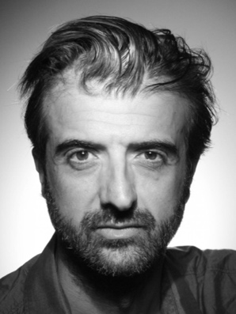Antoine MUCHIR, PhD

Paris, France

**SCIENTIFIC COMMITTEE**

**5th International Meeting on Laminopathies**

Dear Madam, dear Sir,

We are very pleased to organize the 5th International Meeting on Laminopathies, the European Consortium of Lipodystrophies (21-23 May 2025, Cordeliers Campus, Sorbonne University, Paris). This meeting brings together international experts of nuclear envelope proteins and related diseases, including muscular dystrophies, cardiomyopathies, accelerated ageing syndromes such as Hutchinson-Gilford progeria and metabolic disorders. The meeting aims to promote international collaborations to increase the scientific knowledge and improve diagnosis, prevent and manage these diseases.

The 5th International Meeting on Laminopathies is expected to bring together about 150 participants, cardiologists, neurologists, endocrinologists, pediatricians, geneticists and researchers and patients.

The ECLip (the European Consortium of Lipodystrophies) congress (20-21 May 2025) will precede the international meeting on laminopathies. A joint session will bridge the two sessions. As a privileged partner in the care of our patients, your sponsorship will strongly contribute to the success of 5th International Meeting on Laminopathies and demonstrate your commitment to our network and its initiatives, and your support to affected patients.

Please find attached the provisional program. Please note that all support received

from event partners contributes to the logistical funding of the congress and is in no way used to sponsor doctors or the congress scientific committee before, during or after the event.

We thank you for your collaboration and will be delighted to discuss further with you,

Yours sincerely

**5th International Meeting on Laminopathies**

**VENUE**



CAMPUS DES CORDELIERS

Amphithéatre Farabeuf

15 rue de l'École-de-médecine

75006 Paris

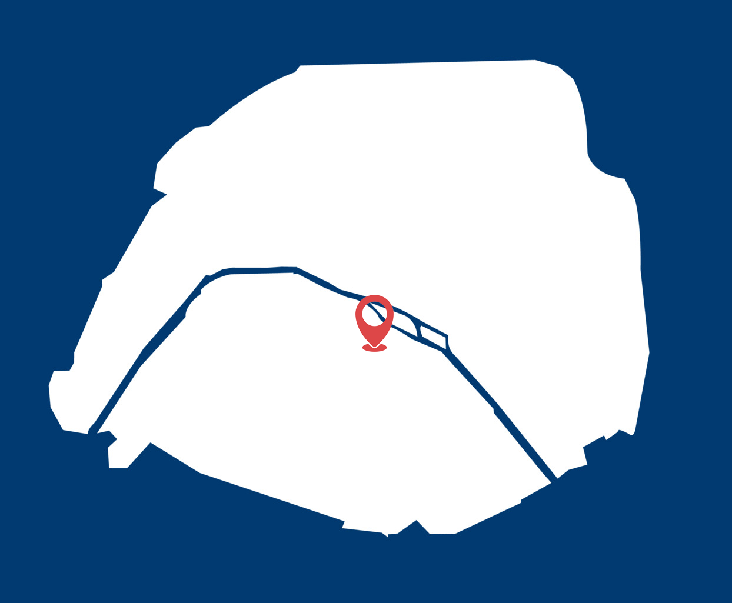

**ACCESS**

The Cordeliers Campus is located in the 6th arrondissement of Paris and easily

accessible by public transport:

Metro: Lines 4 or 10 (Odéon stop)

RER B : Saint-Michel or Luxembourg stations

RER C : Saint-Michel station

Bus: Lines 38, 27, 58 (stop Rue des écoles or Odéon) and lines 63 and 86 (stop Cluny)

**5th International Meeting on Laminopathies**

**PRELIMINARY PROGRAM**

**___________________________________________________________________**

**Wednesday 21May**

14:20 - 14:30 “Introduction and welcoming” *Antoine Muchir, Center of Research in Myology, Institute of Myology, Inserm, Sorbonne University, Paris, France*

**Session| Laminopathic lipodystrophy**

*Chairs: Giovanna Lattanzi, Estelle Nobécourt*

14:30 - 14:45 “*LMNA* mutations and FPLD – new data” *Ferruccio Santini, University Hospital of Pisa, Italy*

14:45 - 15:00 “A lipidomic score to reassess BMI in patients with FPLD2” *Estelle Nobécourt, CHU de Nancy, France*

15:00 - 15:15 “New Developments on FPLD in Men” *David Araújo-Vilar, University of Santiago de Compostela, Spain*

15:15 - 15:30 “Sclerostin and bone metabolism in FPLD2” *Marie-Christine Vantyghem, PRISIS Center, Centre Hospitalier Universitaire de Lille, France*

15:30 - 15:45“Epicardial fat in metabolic laminopathies” *Bénédicte Gaborit, Aix- Marseille University, Inserm, Marseille, France*

15:45 - 16:20 Coffee Break and Poster Viewing

*16:20 - 16:40* “Spatial chromatin rearrangement in lipodystrophic laminopathies” *Philippe Collas, University of Oslo, Norway*

*16:40 - 17:00* “Molecular signatures, physiological features and response to insult in cells isolated from perifacial adipose tissue of Dunnigan patients” *Margherita Maffei, National Council of Research, Pisa, Italy*

*17:00 - 17:20* “How adipocytes are lost in FPLD2?” *Ormand Macdougald, University of Michigan, United States of America*

*17:20 - 17:30* “To be determined” *Giovanna Lattanzi, Institute of Molecular Genetics, Bologna, Italy*

***20:00 Conference Gala Dinner***

**___________________________________________________________________**

**Thursday 22May**

**Session| Common features among laminopathies**

*Chairs: to be determined*

9:00 – 9:20 “Cardiac metabolic alteration in *LMNA* cardiomyopathy” *Wilfried LeGoff, Sorbonne University, Inserm, Paris, France*

9:20 – 9:40 “DNA double-stranded breaks, a hallmark of aging, defined at the nucleotide resolution, are increased and associated with transcription in the cardiac myocytes in *LMNA*-cardiomyopathy” *Ali J Marian, University of Texas Health Sciences Center, Houston, United States of America*

9:40 – 10:00 “Role of lipodystrophy in Hutchinson-Gilford progeria syndrome and therapeutic opportunities” *Vicente Andres, Centro Nacional de Investigaciones Cardiovasculares Carlos III (CNIC), Madrid, Spain*

10:00 - 10:20 “Metabolic similarities between EDMD and lipodystrophy” *Eric Schirmer, University of Edinburgh, United Kingdom*

10:20 - 10:50Coffee Break and Poster Viewing

**Session| Pathogenesis of laminopathies (1)**

*Chairs: Antoine Muchir*

10:50 – 11:10 “Novel insights into the role of nuclear actin in laminopathies”*Maria Chatzifrangkeskou, University of Cyprus, Cyprus*

11:10 – 11:30 “Role of endothelial lamin A/C in age-related cardiovascular disease”*Ignacio Benedicto Centro de Investigaciones Biológicas Margarita Salas (CIB-CSIC), Madrid, Spain, Spain*

11:30 – 11:50 “Proteome wide identification of the endogenous ADP-ribosylome of cardiac tissue in *LMNA* cardiomyopathy”*Deena Marie Leslie Pedrioli, Universität Zürich, Switzerland*

11:50 - 12:10“Splicing alterations in EDMD and different muscular dystrophies.” *Vanessa Todorow Yale University, Boston, United States of America*

12:10 – 12:30 “Nuclear envelope alterations in different muscular dystrophies – tertiary nuclear envelopathies?” *Peter Meinke, University of Munich, Germany*

12:30 - 14:00Lunch and Poster Viewing

**Session| Pathogenesis of laminopathies (2)**

*Chairs: to be determined*

14:00 – 14:20 “Inhibition of poly(ADP-Ribosyl)ation reduced vascular smooth muscle cells loss and improves aortic disease in a mouse model of progeria” *Philippe Guigue, Aix Marseille University, Inserm, Marseille, France*

14:20 – 14:40 “Developmental origins of *LMNA*-cardiomyopathy” *Francesca Rochais, Aix Marseille University, Inserm, Marseille, France*

14:40 – 15:00 “To be determined”

15:00 – 15:20 “To be determined”

15:20 – 15:40 “To be determined”

15:20 – 15:40 Coffee Break and Poster Viewing

**Session| Clinical phenotypes**

*Chairs: to be determined*

## 16:00 – 16:30 “To be determined” *Karim Wahbi, APHP. Paris, France*

16:30 – 17:00 “To be determined” *Georgia Sarquella Brugada, Hopital Sant Joan de Déu, Barcelona, Spain*

**___________________________________________________________________**

**Friday 23May**

**Session| Therapies**

*Chairs: to be determined*

09:00 – 09:30 “Targeting inflammatory pathways to ameliorate cellular and organismal decline in laminopathies”*Susana Gonzalo, Saint Louis University, United States of America*

09:30 – 10:00 “Genome editing in *LMNA* cardiomyopathy” *Jean-Sébastien Hulot, Hôpital Européen Georges Pompidou, Paris, France*

10:00 – 10:30 “Tackling nuclear shape abnormalities as therapy in *LMNA* cardiomyopathy”*Antoine Muchir Sorbonne University, Inserm, Paris, France*

10:30 - 11:00 Coffee Break and Poster Viewing

**Session| Patient’s organizations and round tables**

11:00 – 13:00

**5th International Meeting on Laminopathies**

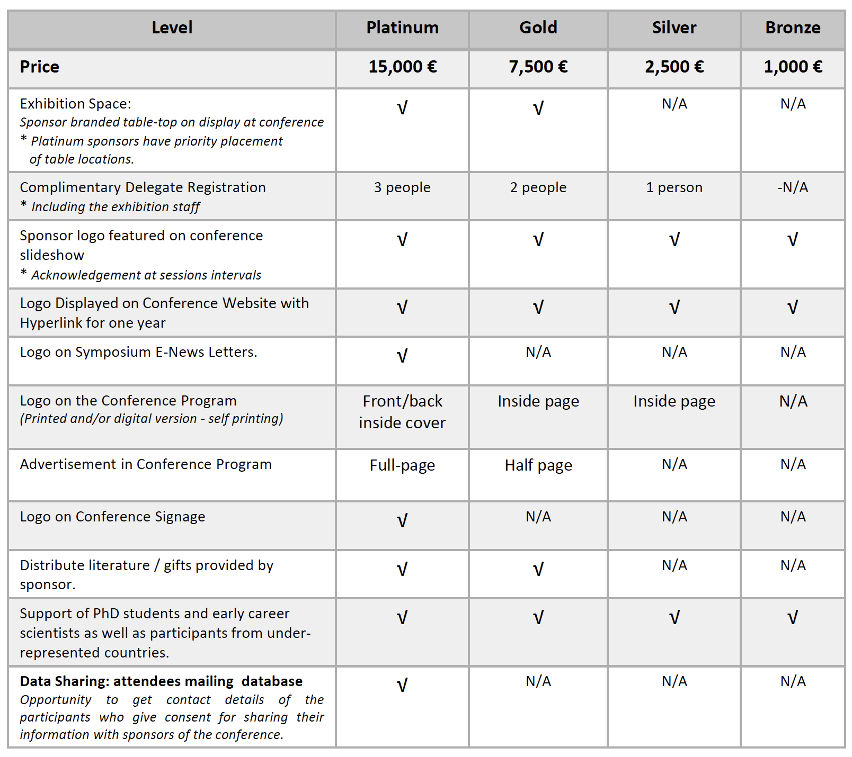**SPONSORSHIP PACKAGES**

**5th International Meeting on Laminopathies**

**RESERVATION FORM**

**___________________________________________________________________**

Company:

First Name: Last Name:

Postal Address:

E-mail:

Phone Number:

**___________________________________________________________________**

Sponsorship Package: £Platinum Sponsor

£Gold Sponsor

£Silver Sponsor

£Bronze Sponsor

**___________________________________________________________________**

Date:

Name:

Signature: